TC 02

Test Scenario : ESS User Login

Test Case Title : Verify login with valid ESS Username and Invalid Password

Test Case Steps : 1) Launch bowser

2) Open URL "https://opensource-demo.orangehrmlive.com/web"

3) Enter Valid Username and InValid Password

4) Click on Login Button

5) Document all the results you received

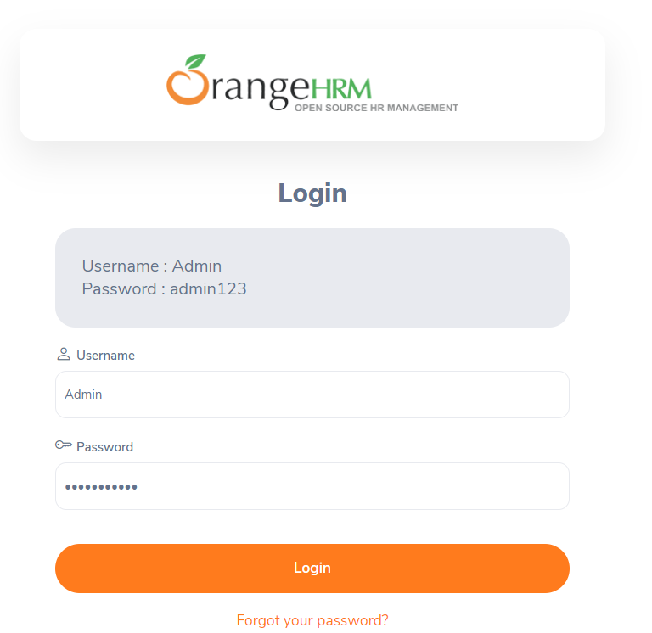

**Now click on Login Button :**

